

**Abstract**

**The electrocardiogram (ECG) is the most widely used diagnostic technique for detecting cardiovascular disease. Manual ECG interpretation, on the other hand, is inefficient and needs highly trained medical professionals. The PhysioNet/Computing in Cardiology Challenge 2020 aims to extract clinical diagnosis from 12-lead ECG data. In this work we proposed deep learning models to classify ECG automatically We will be training our system in 2 phases.We have designed a system that is based on 1-dimensional convolutional and max pooling layers stacked together for feature extraction with binary SVMs for classification. We have used a Frame length of 15000. For each of the scored classes a separate SVC was created. Each SVC was trained in the form of 1 vs rest classifier. For now a linear kernel was used without tweaking any of the hyperparameters. The results indicate that automatically categorizing 12-lead ECGs has significant application value.**

## **Introduction**

The 12-lead ECG is important in clinical diagnostics, involving arrhythmias and other cardiac disorders. Early diagnosis and identification of cardiovascular issues can greatly improve the likelihood of effective treatment.

Over last few years there has been an increase in the number of attempts to detect 12-lead ECG clinical diagnosis, mostly using classic machine learning approaches that need considerable data pre-processing, feature selection, or handmade rules [1-2].Deep-learning algorithms such as Convolutional Neural Networks (CNN) , Recurrent Neural Network (RNN) , Residual Neural Networks (ResNet)  and  their combinations are now used in state-of-the-art algorithms for ECG categorization[3-9].

There are, however, limited research on the classification of 12-lead ECGs. This might be because of lack of sufficient data and a well-defined analysis, which have hindered the

generalizability to classify  12-lead ECGs [10].

We will be using PhysioNet/Computing in Cardiology Challenge 2020 dataset that comprises over 43,000 ECG records with diagnostic labels [11], this study attempts to construct a robust model that automaticallydetects cardiac abnormality in each 12-lead ECG recording. The goal of this project is to create a technique for diagnosing cardiac anomalies from 12-lead ECGs using a deep neural network.

## **Related Work**

In [12], a modified residual convolutional network-based technique is applied. The split attention block is introduced in the modified residual network to improve the ability of significantly convolutional networks to represent features. A network architecture based on stages is used to provide a better way for information to pass through the network's layers.[13] proposes a Residual-CNN GRU neural network with an attention mechanism for categorizing 12-lead ECGs into 24 distinct groups.

To identify 27 clinical diagnoses from 12-lead ECGs, a new deep learning model called SEResNet34 was developed by [14]. A 34-layer ResNet was created for classification purpose.  The design contains 17 sequential skip connections to boost the efficiency of traditional CNN . The identical processes were carried out in each block.

[15] proposes two models, first model is straightforward that can be used as a baseline model, with 5 CNN layers and a smaller receptive field. It is incapable of extracting and identifying complicated features. Model 2 consists of two parallel deep residual neural networks, each with 37 CNN layers.both models took ECG data with varied lengths.The model with deeper layers outperforms the one with shallower layers in classifying ECG abnormalities.

## **Data Pre-Processing**

We used data from 5 different sources. Two sources were divided into training, validation, and test sets; two sources were included just as training data; and one source was included only as test data. The 12-lead ECG recordings were obtained in clinical environment.The specifics of data collection differ depending on the source of the databases, which were compiled all around the world. The label's quality was determined by clinical or research methods, and machine generated labels wereOver-read by a solo cardiologist and evaluated by multiple cardiologists.We have chosen Frame length of 15000. i.e. Sample rate * mean time length.For further pre-processing, Inversion were removed if spotted, Each Frame were Normalized , we also filtered the Bandpass (To remove the extremely high or low amplitude). The Signals were also Padded or truncated accordingly.

## **Proposed Solution**

We have designed a system that is based on 1-dimensional convolutional and max pooling layers stacked together for feature extraction with binary SVMs for classification. We will be training our system in 2 phases.

In the first phase, we will train a complete CNN with dense layers towards the end as described in figure 1. In the second phase, we will use the output of the last layer, before dense layers, as the output of feature extractor and the input to binary SVMs for one-vs-rest classification. For this purpose, the dataset will be organized in such a manner that each binary SVC has data from its main class with positive labels and data for all other classes joined together in the form of negative class. In this manner, each SVC will be able to distinguish one of the classes from the rest.

The main reason for using binary classifiers towards the end is because this is a multi-class multi-label problem in which most of the classes have similar patterns and initial experimentation reveals sigmoid does not perform well in case of similar classes. The reason for using SVMs is because they have performed really well for ECG classification [2] in the past if the ECG signal has been compressed to lower dimensions which in our case will be the output of the feature extractor trained in phase one.

**4.1 Evaluation Metric**

A new scoring methodology was created as an evaluation metric for this years challenge in which misdiagnosis deserves some credit that result in the same diagnosis as the real diagnosis, as determined by the cardiologists. Figure 2 depicts the Reward matrix W for the Challenge diagnoses.





## **Experiments**

The accuracy and loss curves on training and validation datasets for 10 epochs generated from 200 files with and without dropout are shown in Figures 3 and 4.

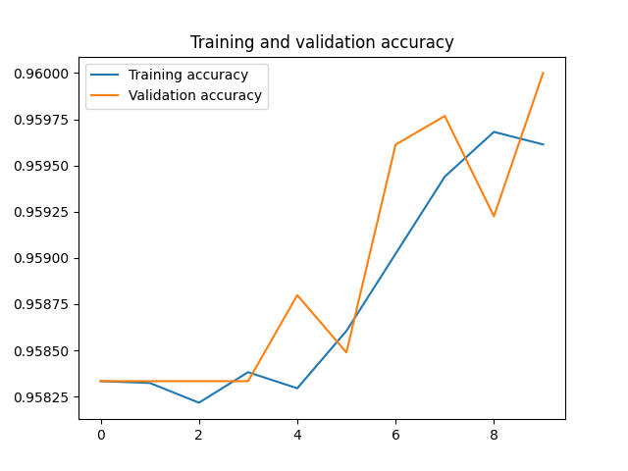









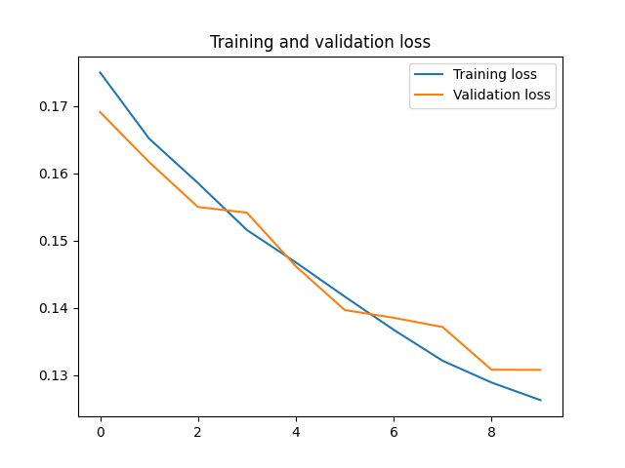



Table 1 illustrates the model's performance on the testing set. We also compared the scores of the best papers submitted for this challenge.

| **Models** | **Challenge Metric Scores** |
| --- | --- |
| **[12]** | **810.00000**0.685 |
| **[13]** | 0.659 |
| **[14]** | 0.653 |
| **[15]** | 0.546 |
| **Proposed Model** | 0.500445 |



## **Conclusions**

We have designed a system that is based on 1-dimensional convolutional and max pooling layers stacked together for feature extraction and binary SVMs for classification. We trained our system in two stages. We received a challenge score of 0.50044. For the futurework, we will resample all data points at a frequency of 500 hz and train on the whole dataset. We can do Support Vector Machine hyperparameter tuning, introduce noise to try to augment the data, and try Resnet or attention-based Convolutional Blocks as proposed in reference papers.

**References**

Kropf M, Hayn D, Schreier G. ECG classification based on time and frequency domain features using random forests. 2017 Computing in Cardiology (CinC). IEEE, 2017: 1-4.

Smíšek R, Hejč J, Ronzhina M, et al. SVM based ECG classification using rhythm and morphology features, cluster analysis and multilevel noise estimation. 2017 Computing in Cardiology (CinC). IEEE, 2017: 1-

Hannun AY, Rajpurkar P, Haghpanahi M, et al. Cardiologist-level arrhythmia detection and classification in ambulatory electrocardiograms using a deep neural network. Nature Medicine, 2019; 25(1):65- 69.

Wang G, Zhang C, Liu Y, et al. A global and updatable ECG beat classification system based on recurrent neural networks and active learning. Information Sciences, 2019; 501:523-542.

Yildirim Ö. A novel wavelet sequence based on deep bidirectional LSTM network model for ECG signal classification. Computers in Biology and Medicine, 2018; 96:189-202.

Sannino G, De Pietro G. A deep learning approach for ECG-based heartbeat classification for arrhythmia detection. Future Generation Computer Systems, 2018; 86:446-455.

Al Rahhal MM, Bazi Y, Al Zuair M, et al. Convolutional neural networks for electrocardiogram classification. Journal of Medical & Biological Engineering, 2018; 38:1014-1025.

Faust O, Shenfield A, Kareem M, et al. Automated detection of atrial fibrillation using long short-term memory network with RR interval signals, Computers in Biology and Medicine, 2018; 102:327-335.

Xiong Z, Nash MP, Cheng E, et al. ECG signal classification for the detection of cardiac arrhythmias using a convolutional recurrent neural network, Physiological Measurement, 2018; 39(9):094006.

Strodthoff N , Wagner P , Schaeffter T , et al. Deep learning for ECG analysis: benchmarks and insights from PTB-XL. 2020.

Erick A. Perez Alday, Annie Gu, Amit Shah, Chad Robichaux, An-Kwok Ian Wong, Chengyu Liu, Feifei Liu,Ali Bahrami Rad, Andoni Elola, S alman Seyedi, Qiao Li, Ashish Sharma, Gari D. Clifford, Matthew A. Reyna. Classification of 12-lead ECGs: the PhysioNet/Computing in Cardiology Challenge 2020. Physiol. Meas.

Multi-label Classification of Electrocardiogram With Modified Residual Networks Shan Yang1 , Heng Xiang1 , Qingda Kong1 , Chunli Wang1 1Chengdu Spaceon Electronics Co, Ltd, Chengdu, China.

Utilization of Residual CNN-GRU With Attention Mechanism for Classification of 12-lead ECG Petr Nejedly, Adam Ivora, Ivo Viscor, Josef Halamek, Pavel Jurak, Filip Plesinger Institute of Scientific Instruments of the Czech Academy of Sciences, Brno, Czech Republic.

Automatic Detection and Classification of 12-lead ECGs Using a Deep Neural Network Wenxiao Jia 1 , Xian Xu 1 , Xiao Xu 1 , Yuyao Sun1 , Xiaoshuang Liu1 1 Ping An Health Technology, Beijing China.

Automatic 12-lead ECG Classification Using Deep Neural Networks Wenjie Cai, Shuaicong Hu, Jingying Yang, Jianjian Cao University of Shanghai for Science and Technology, Shanghai, China